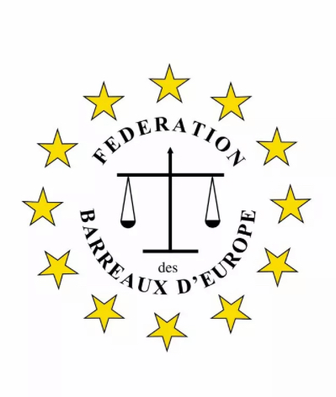

**ADR AWARDS**

**FBE Mediation Commission**

**The ADR FBE Awards was created by the FBE Mediation Commission in 2023 in order to promote the dissemination and recognition of actions carried out in the ADR and Mediation field.**

**It has been agreed that in the 2023 convocation, the prize will be awarded to the Best Mediator of 2024 for their work on Mediation projects.**

**In order to submit nominations for the Awards in the above category, we would appreciate it if you could provide us with the necessary information below.**

**Information of the person that is being nominated or eligible for the Awards:**

**Name …………………………………………………………………………..........**

**Country ………………………………………………………………………………**

**Telephone…………………………. email…………………………………………**

**Information related to the career, work, projects of the nominated person:**

**……………………………………………………………………………..**

**……………………………………………………………………………..**

**……………………………………………………………………………..**

**……………………………………………………………………………..**

**……………………………………………………………………………..**

**……………………………………………………………………………..**

**……………………………………………………………………………..**