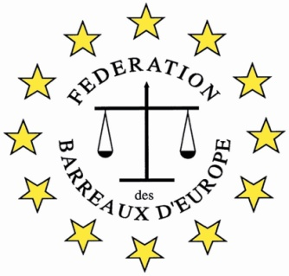

FBE 4th International Young Lawyers’ and Law Students’ Human Rights Oratory Competition, Gdansk 2024

WHERE?
In Gdansk, Poland

WHEN?
6 and 7 September 2024

WHO?

Law Students and lawyers up to 5 years qualified

WHY?
The Competition is a great opportunity to:
- practice and improve oratory skills
- learn to present a case to an international audience of lawyers
- develop legal English and general oral English skills
- meet with lawyers from jurisdiction across Europe
- meet young lawyers from Gdansk
- enjoy the historic city of Gdansk

THE ORGANIZATION
The Competition is organized by the European Bars Federation (FBE)/ its Human Right Commission and will be hosted by the Gdansk Bar.

WHAT YOU WILL DO
Prepare a 10 minutes speech on: “What is the impact of legislation and litigation on climate change” to be presented to an International Jury in Gdansk with other participants from different countries.

If selected amongst the four best contestants, defend a position against an opponent on another topic the following day.

HOW TO APPLY
Applications should be completed on the accompanying form and approved by the your Bar Association. Please contact your Bar and send your application to the relevant person. The form must then be sent to fbehumanrightscompetition@gmail.com by 12.00 midday on 9 August 2024

